**Experiment 2**

**Density**

**Pre-lab Assignment**

Before coming to lab:

* Read the lab thoroughly.
* Answer the pre-lab questions that appear at the end of this lab exercise.

**Purpose**

Determine the density of solids and liquids. Explore the importance of recording data to the proper significant figures and performing calculations in a laboratory.

**Background**

**Density** is the mass of an object divided by the volume of the object.

D= $\frac{M}{V}$

In order to determine the density of an item, we will need to determine its mass and volume. The standard unit for measuring mass in a lab is the gram. Think about liquids- what units do you typically report the volume of a liquid in? What about for a sugar cube, what volume is the most appropriate?

A regular object like a sugar cube can be measured with a ruler so we might report the volume in centimeters cubed (cm3). An irregular object like the plate pictured below can be measured by using a technique called **volume by displacement**. A liquid (typically water) is placed in a graduated cylinder and the volume of a liquid is measured. Then the irregular object is placed in the liquid and the volume is measured again. The change in volume is the irregular object’s volume. This measurement is often made using a graduated cylinder and recording a volume in Liters or milliliters (mL).

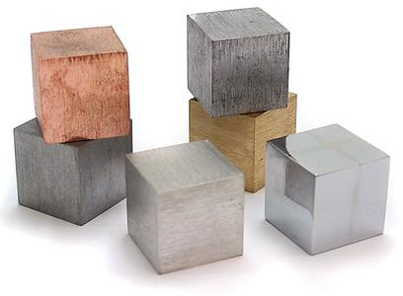 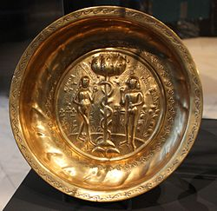

*Figure 1. (a) Regular object of metal blocks with the same width, length, and height. (B) An irregular object of a plate made of metal*.

Density is a very useful physical property that is specific to an objects identity. Any amount of that substance will always have the same density. For example, a 5 pound bag of sugar and one sugar cube both have the same density. Because of this fact, you could use the density of an object to determine the identity of the object. For example, if you measured the density of a metal and compared it with a table of known densities you could identify what the metal plate is made of.

This lab will explore the measurement of regular and irregular objects. Your final task will be to measure the density of an unknown solid and determine its identity.

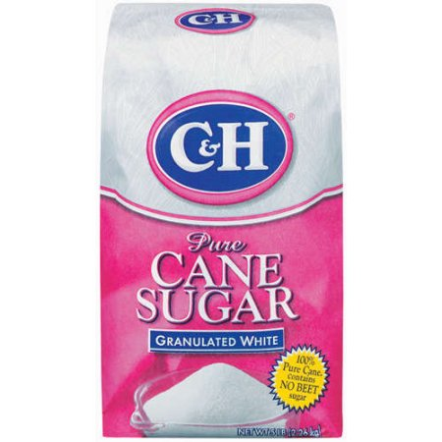 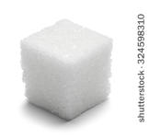

*Figure 2. (a) Five pound bag of sugar (b) A single sugar cube. Both have the same density.*

We will also gain experience using common laboratory equipment, and recording measurements correctly based on the idea of significant figures in this experiment . When working with the top loader balance, graduated cylinder, ruler, and volumetric pipet in lab today please be careful to record the appropriate number of decimal places, as shown in the table below.

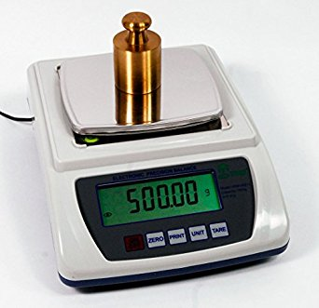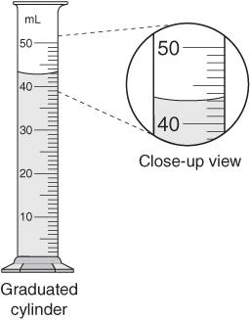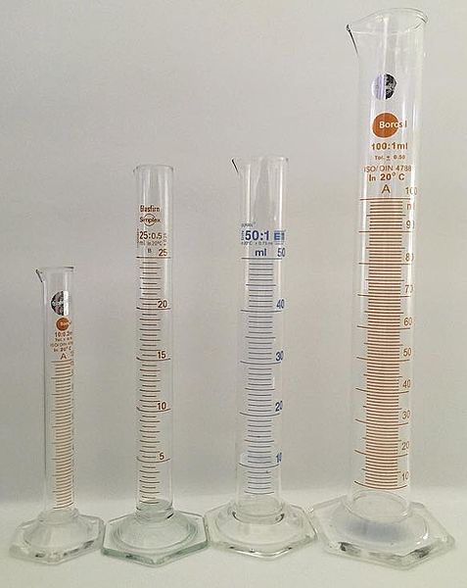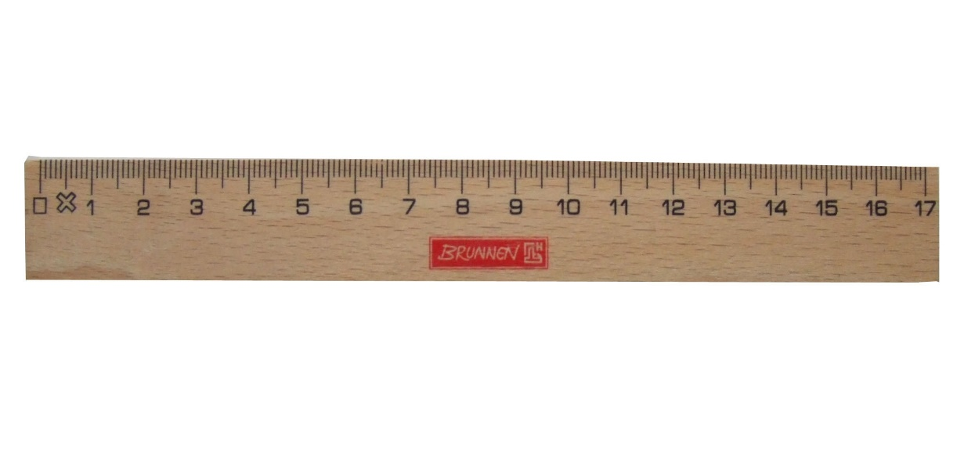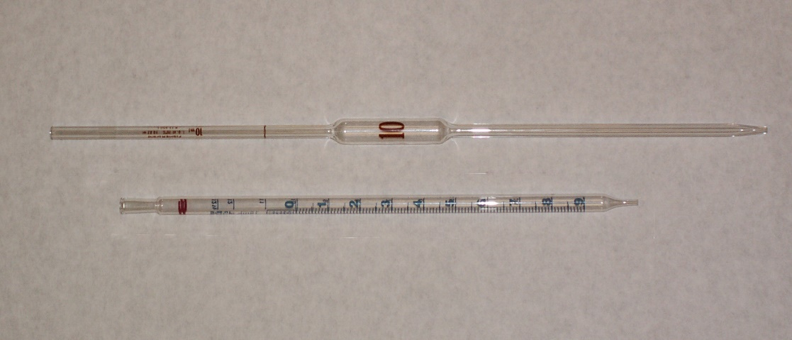

E

D

C

B

A

*Figure 3. (A) Top loader balance (B) 50 mL graduated cylinder showing a close-up view (C) Actual 50 mL graduated cylinder (D) ruler showing cm (E) 10.00 mL glass volumetric pipet*

**Table 1. Common Units Measured in the Lab with Appropriate Significant Figures**.

|  |  |  |
| --- | --- | --- |
| **When using a** | **Record to the nearest decimal place** | **Example** |
| Thermometer | Tenth | 25.2 °C |
| Ruler | Hundredth | 3.55 cm |
| Pipet | Hundredth | 10.00 mL |
| Graduated Cylinder | Tenth | 50.0 mL |
| Top Loader Open Balance | Hundredth | 100.54 g |
| Analytical Closed Balance | Ten thousandth | 100.5432 g |

**Sample Calculations**

**Example 1 Determining the Density of a Regular Object :**

**Step 1**. Record the dimensions of the object.

When measuring a block you should record the length, width, and height

For example,

Width= 4.25 cm, Height = 4.35 cm, Length =10.24 cm

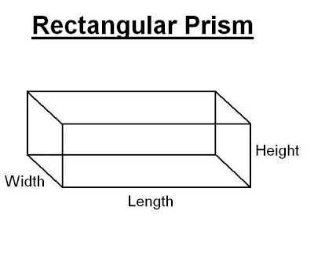

**Step 2**. Calculate the volume using the formula:

Volume = Length x Width x Height

This produces a cubic unit.

For lab today please record your units in centimeters cubed (cm3).

V = 10.24 cm x 4.25 cm x 4.35 cm

= 189.312 cm3

**Step 3**. Keep track of the number of significant figures in the calculation.

For this example the significant figures is limited to the LOWEST number of significant figures the width and the height have three significant figures.

Volume =189 cm3

**Step 4**. Put the mass and volume together to calculate the density.

If you measured the mass to be 167.45 grams.

The density would then be found by D = $\frac{M}{V}$ = $\frac{167.45 g}{189 cm^{3}}$ = 0.884519 $\frac{g}{cm^{3}}$ = 0.885 $\frac{g}{cm^{3}}$

The final answer should be rounded to three significant figures as the limiting number of significant figures comes from the width and height of the object.

|  |
| --- |
| **Example 2 Determining the Density of an Irregular Object such as a rubber stopper:**  **Step 1**. Add water to the graduated cylinder to half of the column.  Add 50.0 mL of water to a 100.0 mL graduated cylinder or add 25.0 mL of water to a 50.0 mL graduated cylinder. Record this as the **initial volume** before the object is placed in the cylinder.  **Step 2**. Add the irregular object to the graduated cylinder making sure to not splash any water out of the cylinder. Record the **final volume** after the object + water are combined.  **Step 3**. Calculate the volume of the irregular object. Keep track of the number of significant figures in the calculation.  For this example the initial volume of a graduated cylinder was 25.0 mL and the final volume after a rubber stopper was added was 35.2 mL.  Volume of the irregular object =Vfinal – Vinitial    V= 35.2 mL – 25.0 mL = 10.2 mL  **Step 4**. Put the mass and volume together to calculate the density. *Rubber stopper graduated cylinder*  If you measured the mass to be 13.77 grams.  The density would then be found by D = $\frac{M}{V}$ = $\frac{13.77 g}{10.2 mL}$ = 1.35 $\frac{g}{mL}$ The final answer should be rounded to three significant figures as the limiting number of significant figures comes from the volume of the object. |

**Procedure**

**Part A. Density of a Regular Object**

1. Measure the dimensions of the sugar cube in centimeters to the nearest HUNDRETH of a decimal place using a ruler.
2. Weigh the sugar cube on the top loader balance and record the mass on your data sheet. Be sure to record all the digits on the scale.
3. Calculate the density.
4. Check to make sure the density is within range of 1.15 to 1.35 g/cm3.

**Part B. Density of an Irregular Object**

1. Fill a 50 mL or 100 mL graduated cylinder half full with water.
2. Record the initial volume of water to the nearest TENTH of a decimal.
3. Weigh a rubber stopper and record the mass on your data sheet.
4. Slowly add the rubber stopper to the graduated cylinder so that no water splashes.
5. Record the final volume of the object to the nearest TENTH of a decimal place.
6. Calculate the density
7. Check to make sure the density is within range of 1.2 to 1.6 g/mL

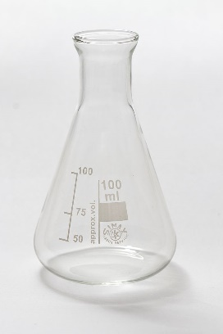**Part C. Density of Water**

1. Weigh an empty 125 mL Erlenmeyer flask fitted with a solid stopper and record the mass to the nearest HUNDRETH of a decimal in your data table
2. Using a DI water bottle squirt water through the pipet to rinse it
3. Fill your smallest beaker with deionized water from the tap at the back of the lab.
4. Squeeze the pipet bulb with one hand to push the air out. Then attach the bulb to the top of the pipet and draw water from the beaker into the glass pipet. Stop when you have gone about 5 cm past the line near the top of the pipet. Lift the bulb off and place your finger over opening at the top of the pipet *Erlenmeyer Flask*

*If you run out of air in the pipet bulb, take the bulb off the top of the pipet and place your finger over the opening. Then squeeze the pipet bulb again. Replace the bulb over the pipet opening and continue drawing the liquid up the pipet.*

To get exactly 10.0 mL of liquid, slowly lift your finger to change the pressure inside the pipet until the liquid meniscus sits directly over the line.

1. Transfer the 10.00 mL water from the pipet to the pre-weighted Erlenmeyer flask. Stopper the flask. *Note: A small amount of the water may remain in the pipet after it drains out. This is normal. It is not necessary to “blow” it out.*
2. Measure the mass of the water, Erlenmeyer flask and stopper, and record the mass on your data table.
3. Calculate the density of the water.
4. Empty the water from the Erlenmeyer flask down the sink.
5. Repeat the experiment for a second trial. You will need to weight the Erlenmeyer flask empty again since it will be wet and will a slightly different amount than in the first trial.
6. Average your answer for the two trials: Average Water Density = $\frac{Trial 1+Trial 2}{2}$

**Part D. Density of Unknown Liquid**

1. Obtain an unknown sample from your lab instructor. Make sure to record the UNKNOWN NUMBER on your data table.
2. Weigh an empty 125 mL Erlenmeyer flask fitted with a solid stopper and record the mass to the nearest HUNDRETH of a decimal in your data table
3. Pour about 30 mL of your unknown liquid into a small beaker.
4. Squeeze the pipet bulb with one hand to push the air out. Then place the bulb over the opening to draw about 5 mL of unknown liquid up into the glass pipet.
5. Turn the pipet horizontally and slowly swirl the liquid to coat the insides of the pipet. This is called **conditioning** the glass to make sure the unknown liquid creates a film over the glass walls and that no other liquids are present.
6. Rinse the remaining ~5 mL of liquid into the sink.
7. Pipet 10.0 mL of unknown liquid making sure to hold enough pressure inside the pipet until the liquid meniscus sits directly over the line on the pipet.
8. Transfer the pipetted 10.0 mL of unknown liquid into the weighed Erlenmeyer flask. Stopper and record the mass on your data table.
9. Calculate the density.
10. Repeat the experiment for a second trial.
11. Average the two trials: Average Density = $\frac{Trial 1+Trial 2}{2}$

**Part E. Density of an Unknown Solid**

1. Select an unknown solid from the container
2. Record the dimensions of the solid in centimeters to the nearest HUNDRETH of a decimal place using a ruler.
3. Weigh the solid on the top loader balance and record the mass on your data sheet.
4. Calculate the density of the solid.

**Name______________________**

Lab Section_____________ Date:_____________Lab partner name:_____________________

**Density Lab Report Data Tables**

**Part A Regular Object**

|  |  |  |
| --- | --- | --- |
| 1. Length of sugar cube |  | cm |
| 1. Width of sugar cube |  | cm |
| 1. Height of sugar cube |  | cm |
| 1. Calculate the Volume |  | cm3 |
| 1. Mass of sugar cube |  | g |
| 1. Calculate the Density of sugar cube |  | g/cm3 |

**Show work for the calculation of the volume and the density of the sugar cube:**

**Part B Irregular Object**

|  |  |  |
| --- | --- | --- |
| 1. Volume initial in graduated cylinder |  | mL |
| 1. Volume final in graduated cylinder |  | mL |
| 1. Change in volume (Line 2- Line 1) |  | mL |
| 1. Mass of Irregular object |  | g |
| 1. Calculate the density of the object |  | g/mL |

**Show the calculations for the volume and density below:**

**Part C Density of Water**

|  |  |  |  |
| --- | --- | --- | --- |
|  | Trial 1 | Trial 2 |  |
| 1. Mass of flask and stopper |  |  | g |
| 1. Mass of flask, stopper, and water |  |  | g |
| 1. Mass of water |  |  | g |
| 1. Volume of water |  |  | mL |
| 1. Density of water |  |  | g/mL |
| 1. Average density |  | | g/mL |

**Show calculation of mass of water and density:**

**Part D Density of Unknown Liquid Unknown Number on Vial 20-________________**

|  |  |  |  |
| --- | --- | --- | --- |
|  | Trial 1 | Trial 2 |  |
| 1. Mass of flask and stopper |  |  | g |
| 1. Mass of flask, stopper and liquid |  |  | g |
| 1. Mass of liquid |  |  | g |
| 1. Volume of liquid |  |  | mL |
| 1. Density of liquid |  |  | g/mL |
| 1. Average density |  | | g/mL |

**Show calculation of mass of liquid and density:**

**Part E. Density of Unknown Solid**

|  |  |  |
| --- | --- | --- |
| 1. Length of unknown solid |  | cm |
| 1. Width of unknown solid |  | cm |
| 1. Height of unknown solid |  | cm |
| 1. Calculate the Volume |  | cm3 |
| 1. Mass of unknown solid |  | g |
| 1. Calculate the Density of unknown solid |  | g/cm3 |

**Show calculations for the Volume and the Density:**

**Post Lab Due:___________ Lab Section:__________ Name_______________________**

Show all calculations for full credit. Your number of significant figures in your final answer will be graded!

1. **Find the density of a regular object.**

A chunk of metal with dimensions of 4.57 cm x 5.73 cm x 12.9 cm that weighs 315.74 grams.

____________g/cm3

1. **Find the density of an irregular object.**

A stack of **10** pennies weighing 26.55 grams is placed in a graduated cylinder containing water. The initial volume of water is 50.0 mL and the final volume of the water and pennies 53.3 mL. What is the density of **ONE penny**?

Density of ten pennies= ___________g/mL Density of one penny = __________g/mL

1. **Find the density of a liquid.**

An empty flask weighs 145.29 grams. A flask with **10.0 mL of a liquid** weighs 152.99 grams. Find the density of the liquid.

____________g/mL

1. **Identify the mystery substance from its density.**

Identify an unknown object with a mass of 19.75 grams and a volume of 25.0 mL

|  |  |
| --- | --- |
| Substance | Density in g/mL |
| Hexane | 0.658 |
| Gasoline | 0.700 |
| Ethanol | 0.772 |
| Acetone | 0.790 |
| Mineral Oil | 0.850 |
| Water | 0.998 |

Unknown Identity ______________

1. **Using density as a conversion factor.**

If a piece of aluminum foil weighs 0.225 grams and has the length of 5.00 cm, and a width of. 4.50 cm., Find the **THICKNESS** of the foil in centimeters. *The density of aluminum is 2.70 g/cm3*

Step One. Find the Volume of the Aluminum Foil

__________cm3

Step Two. Find the Thickness of the Aluminum Foil

_______________cm

1. Draw the placement of each object in the cylinder below based on the density of the objects:

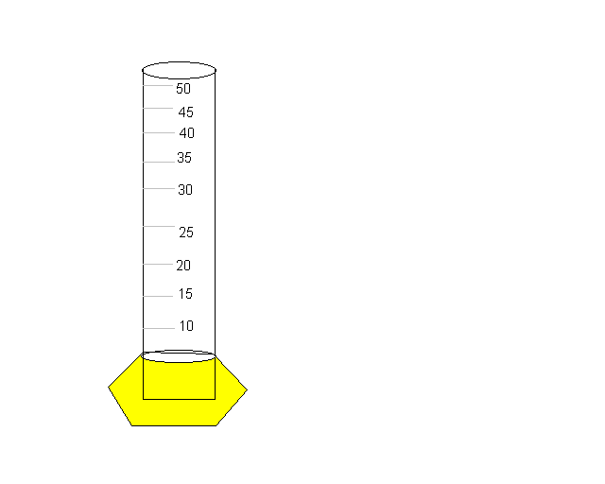

Mineral Oil 0.82 g/mL

Water 0.995 g/mL

Mercury 13.6 g/mL

a) Silver ring 10.5 g/cm3 b) Gold bar 19.3 g/cm3 c) Plastic 0.690 g/cm3

**Name__________________________**

**Pre Lab Assignment for Density**

**Due:_______________ Lab Section:__________**

Show all calculations for full credit. Your number of significant figures in your final answer will be graded!

Important equations: Volume = L x w x h Density = $\frac{mass}{volume}$ Volume = $\frac{mass}{density}$

You will be graded based on reporting accurate significant figures and units. Please report your final answer with the correct units and significant figures for full credit.

1. Define the following key terms:
   1. Density
   2. Volume by displacement
   3. Regular object
   4. Irregular object
2. What key pieces of lab equipment are used to transfer ten mL of liquids in this experiment ? How many significant figures are recorded when using it and transferring ten milliliters of sample?
3. Explain the steps used to find the volume of an irregular object.
4. You measure the initial volume of water in a graduated cylinder to be 23.5 mL and the final volume to be 29.8 mL after placing a rubber stopper in the water. If the rubber stopper weighs 14.395g, then what is the density of the rubber stopper?
5. A block has a length of 4.10 cm, width of 2.50 cm, and height of 5.25 cm and weighs 42.735 g. Calculate the density of the block.
6. Would the block in question 5 float or sink if placed in water which has a density of 0.995 g/mL?